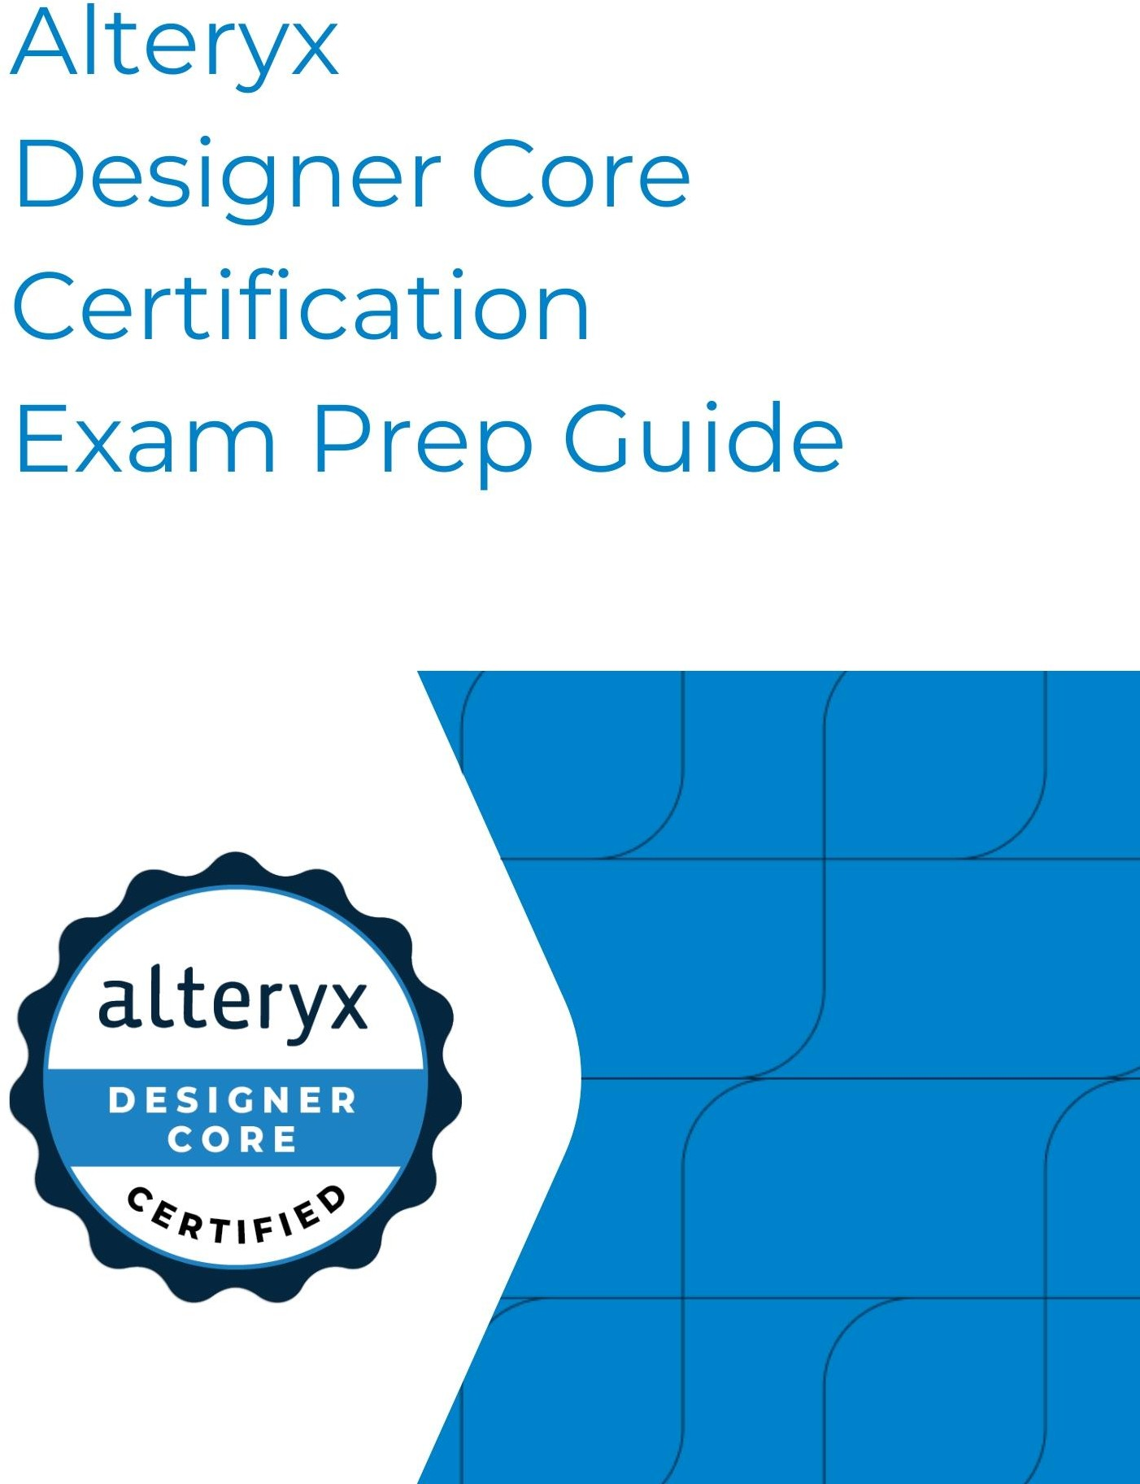

## Earning your Core Certification takes you to a new level.

The world is full of dirty data and complex problems. Luckily, there are analytic adventure seekers like you who want to explore all that Alteryx Designer holds. Whether you are brand-new or a seasoned veteran, the Alteryx Certification Program provides you with ways to continue learning and a place to prove your Alteryx analytic skills.

### The Core exam is designed to help you demonstrate your skills: it is free, online, on demand, and open book.

#### Contents

Exam Overview 3

Exam Blueprint Summary 4

Designer Tools on the Core Exam 4

Journey to Certification Success 5

Test Tips 7

Exam Resources 8

Learning Resources 10

Full Core Blueprint 13

Appendix 14

# Exam Overview

The Alteryx Designer Core Certification exam tests your knowledge of the “core” toolset in Designer and your ability to apply your knowledge and use the tools to solve real-world problems. The core toolset includes the tools that are used most often in Alteryx Designer and are fundamental to data preparation and analysis.

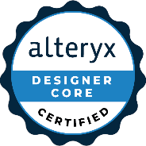**AUDIENCE:** Everyone with an Alteryx Community profile!

**EXPERIENCE LEVEL:** Intermediate

**PRICE:** Free

**EXAM TYPE:** Online, on demand

**TIME ALLOTTED:** 2 ½ hours

**VERSION:** The exam tests on the 22.1 version of Desktop Designer **with the AMP Engine disabled***.* **ATTEMPTS:** One attempt every 7 days

**QUESTIONS:** 80

**QUESTION TYPES:** Multiple-choice, practical application, matching, and multiple-response

**POINT VALUES:** 1 point for multiple-choice, matching, multiple-response, and practical application. Partial credit is awarded for matching and multiple-response questions (“Select THREE options”).

**POLICY VIOLATIONS:** You may not receive assistance from another person, allow another person to take the exam on your behalf, plagiarize any exam answers, share exam content, create more than one account for additional exam attempts, or use unauthorized publications of exam answers. Review the Alteryx Certification Agreement and Policies for more details. Policy violations will result in removal of certifications and a possible ban from the Alteryx Community.

**BADGE AND CERTIFICATION:** Within 48 hours of passing the exam, every user will receive an email from our virtual badge partner Credly. A Credly profile is required to access the Core Certificate and virtual badge that can be shared online.

**RECERTIFICATION:** The Alteryx Designer Core Certification expires after 2 years. You may retake and pass the Alteryx Designer Core exam OR the Alteryx Designer Advanced exam to renew your Core certification. After the first year of certification, you become eligible to retake the exam to recertify.

**SCORING:** Alteryx Certification exams are pass or fail exams. The exams are scored against a minimum standard established by Alteryx subject matter experts who follow certification industry best practices and guidelines. As with most Certification programs, Alteryx does not publish exam passing scores or rates as exam questions and cut scores are subject to change without notice.

# Exam Blueprint Summary

###### For the detailed blueprint, refer to page 12.

|  |  |
| --- | --- |
| **Core Blueprint** | **% of the Exam** |
| I. General Designer Knowledge and Optimization | 13% |
| II. Input/Output Data and Preparation | 36% |
| III. Blend Data and Parse | 26% |
| IV. Transform Data | 25% |
| **TOTAL** | **100%** |

# Designer Tools on the Core Exam

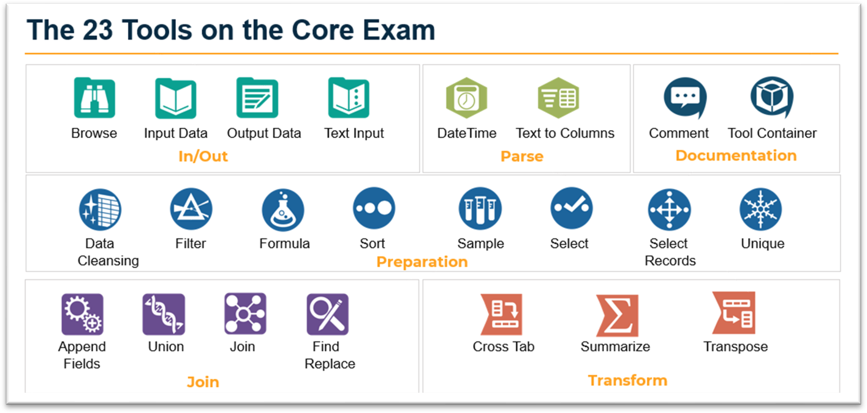

# Journey to Certification Success



##### LEARN

1. Begin your learning journey at [Alteryx Academy](https://ayxlearn.info/Academy-on-Community)! Our Academy Team is constantly adding cost-free content and new methods of training to help our Designer users be confident and knowledgeable. Check out our learning paths, interactive lessons, Weekly Challenges, and more to help you learn all that Designer has to offer. In addition to free training, Alteryx now offers instructor-led training (ILT) in our Learning Marketplace at an enterprise level.
2. Analyze data that is meaningful to you. Formulate questions and build workflows that give insight into your own data. This is a critical step in the learning process—you will not only apply what you have learned, but also be able to visualize how Designer can help you perform your job more efficiently and effectively.

##### For a full description and examples of resources, see page 10.

##### PREPARE

1. Review the detailed exam blueprint to understand exactly what is on the exam. Identify

anything you don’t recognize or understand well and use your resources to learn more.

1. Take the [practice exam.](https://ayxlearn.info/CoreCertPracticeTest)
2. Review and become familiar with your resources (see page 8). These are your lifeline during the exam!
3. If you have already taken the exam, take advantage of the results email to help you pinpoint the areas where you can focus your preparation.

##### For more tips and tricks for exam preparation, see page 7.

##### [TEST](https://community.alteryx.com/t5/Certification/bd-p/product-certification)

1. After you select the link to take the exam, you will be directed to our exam platform ClassMarker. On the next screen you will enter your first name, last name, email address, and Community username. All users are required to agree to our [policies](https://ayxlearn.info/CertificationAgreement) prior to accessing the exam.
2. During the exam, you will be prompted with one question at a time. For each question, you will have the ability to do the following:
   1. Select an answer and continue to the next question.
   2. Not select an answer and continue to the next question.
   3. Bookmark the question and return to it later.
3. Once you reach the last question, you will have the option to submit your answers. If you run out of time prior to submitting your answers, the exam will be submitted for you automatically.
4. Upon completion of your exam, a pass/fail result will appear, and a score report will be emailed to you. This report will include information on your task level performance for education and training purposes. Please note: Alteryx performs post exam session review for improprieties. If any improprieties are discovered, credentials will be revoked, and accounts may be suspended. Please see [Alteryx’s Certification policies](https://ayxlearn.info/CertificationAgreement) for additional information.
5. If you do not pass on your first attempt, don’t fret! You are eligible to retake the exam after 7 days, so spend that time refining your skills and becoming more familiar with your resources.

Once you have passed the Core exam, continue your certification journey by becoming Advanced Certified, share your knowledge on the Alteryx Community, or join a user group!

### Passing the exam is not the end of your certification journey—it is just the beginning of your Alteryx Designer adventure! Continue learning and take your career to new heights!

# Test Tips

##### Read Carefully



Read each question carefully before answering. Pay close attention to tool configurations, screenshots, and data sets. Just as in real life data analytics, the details matter!

##### Use Your Resources



Prior to beginning your exam, **have all your resources up and ready**. Use multiple screens if available and spend some time getting organized.

##### Pace Yourself



Allot about 75 seconds for each 1-point question and 4 minutes for each practical application question. If you finish early, use the remaining time to go back and check your answers. Use the full 2.5 hours.

##### Checkbox Checked with solid fillAnswer Every Question

In the exam platform, use the Bookmark feature to flag questions you would like to come back to and review later. Select **See all questions** to view all unanswered and bookmarked questions. Many questions provide partial credit, so it is worth attempting to answer every question even if you aren’t 100% sure.

##### Reflect, Review, Refine



If you do not pass your first attempt, you now have a new study aid! Your exam results will be emailed to you with a breakdown of how you performed in each category. Take those results and use them to pinpoint your study efforts.

# Exam Resources

##### Practice Exam*

Test out your skills with the [Core Certification Practice Exam](https://ayxlearn.info/CoreCertPracticeTest)*. The exam includes 15 questions along with explanations of why the answers are correct, so you can continue learning while testing.

*The practice exam is not a true representation of the testing environment. It is a series of questions similar to those found on the exam.

##### One Tool Examples

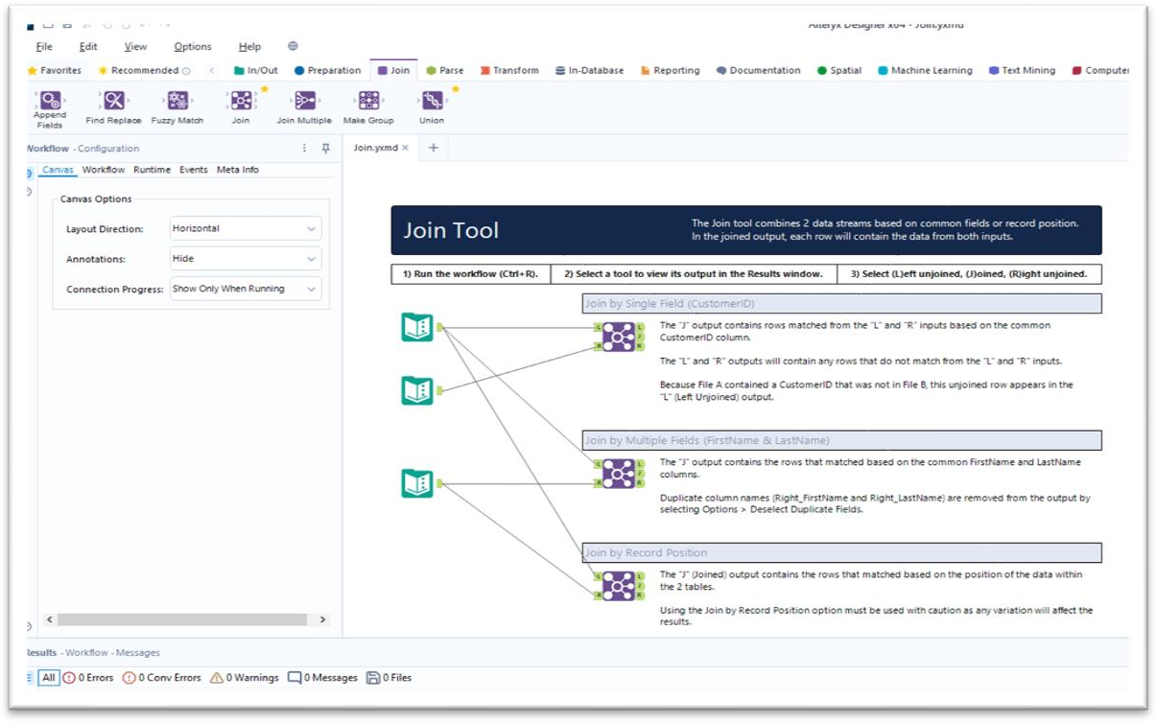Within Designer itself, every tool has a One Tool Example. One Tool Examples are sample workflows that demonstrate different configuration options for one tool at a time. Right-click the tool for a full menu or select the tool to access the direct link to **Open Example**. Don’t forget to select **Run** to check out the tool in action!

##### Help Documentation

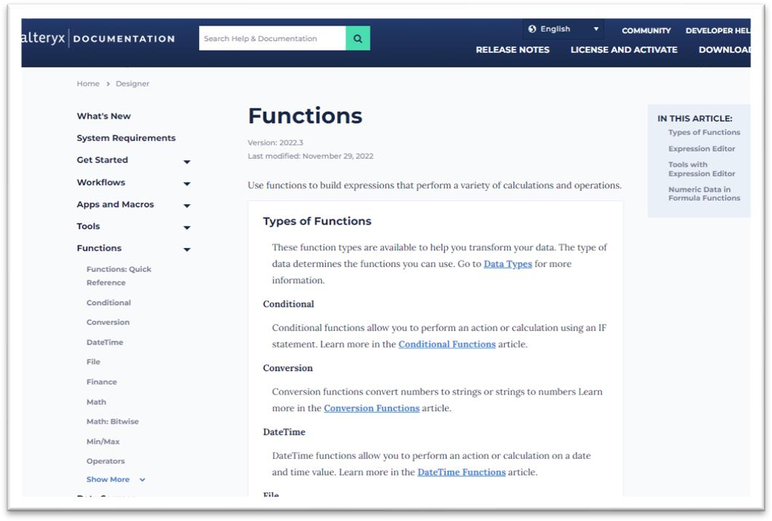The holy grail of information is found in our **Support** > **Help Documentation**. Here you will find the user manual for Designer as well as other products. The documentation includes tool descriptions, explanations of configurations, conditional functions, and so much more. To access Help Documentation from Designer, right-click any tool in the Tool Palette and select **Help**.

##### [Alteryx Community Tool Mastery Index](https://ayxlearn.info/DKB-Tool-Mastery-Index)

The Alteryx Community is a powerhouse of information! Many blogs have been created that explain different ways to solve problems using Alteryx Designer. The Tool Mastery Series is a compilation of Knowledge Base contributions that introduce diverse working examples for Designer tools. Every Designer tool has a blog post dedicated to it with a detailed analysis of the tool.

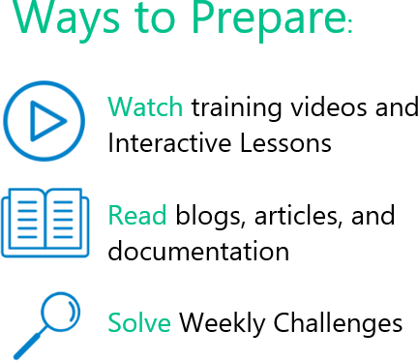

# Learning Resources

##### Alteryx Learning Marketplace

The Alteryx Learning Marketplace is a subscription-based learning platform designed for individuals and businesses seeking to enhance their data analytics skills.

Subscriptions provide you with access to both instructor-led training courses delivered by professional instructors and product experts, and self-paced digital learning paths for 24/7 training.

Your Learning Marketplace Subscription includes:

* Unlimited access to self-paced digital learning lessons and learning paths
* Instructor-led training courses in the Learning Marketplace
* Real time training delivered by an authorized instructor
* Recording of every course taken for review at any time
* Small learning environment with a maximum of 12 learners at a time
* One voucher for a specialized certification exam: Designer Expert or Predictive Master
* Access to subscription-only content
* Certificates of completion and full transcript to track your learning

The Alteryx Learning Marketplace Subscriptions are currently only available for purchase by contacting your Account Executive or the Authorized Training Partner (ATP) contact information provided on the course listing.

##### Recommended Course

Alteryx Designer Core

This instructor-led training course provides the information that you need to get started with Alteryx Designer. You will learn how to build scalable workflows, use the necessary tools to build analytic processes, and overcome challenges when analyzing data.



##### Getting Started Learning Path

The [Getting Started Learning Path](https://ayxlearn.info/LP-Getting-Started) is an extremely valuable guided curriculum. Interactive lessons, articles, and hands-on activities allow you to build your knowledge and apply your skills. This learning path is the cornerstone of your Alteryx Designer learning journey.

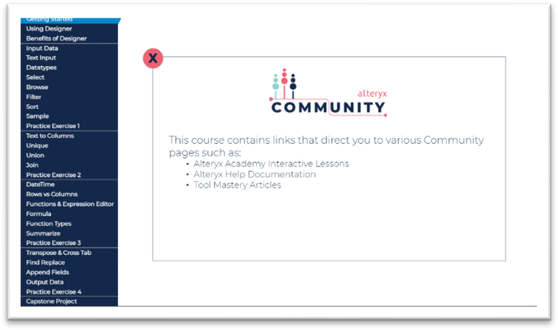

##### Interactive Lessons

Keep up the pace of your learning with our guided curriculum. Each lesson is interactive and provides st ep by step instructions. **Getting Started** is naturally a great place to start, and then continue learning by exploring all the available lessons .

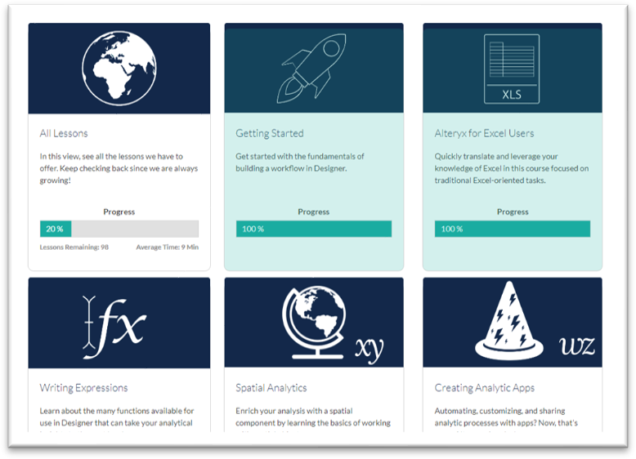

##### Weekly Challenges

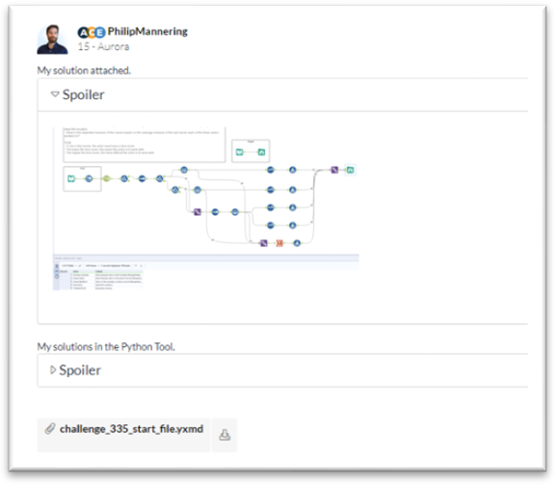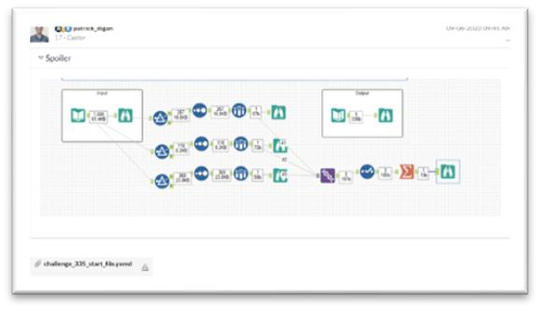

[Weekly Challenges](https://ayxlearn.info/WeeklyChallenge) are a great way to put your skills into action and prepare for the practical application questions on the exam. There are over 350 Weekly Challenges organized by skill level and topic. Try solving the challenge on your own first; if you get stuck, look at how others solved it and learn from their expertise. The following suggested challenges focus on tools covered on the Core exam. Read a scenario, download the provided dataset, and find the

answer using Designer. Here’s an example:

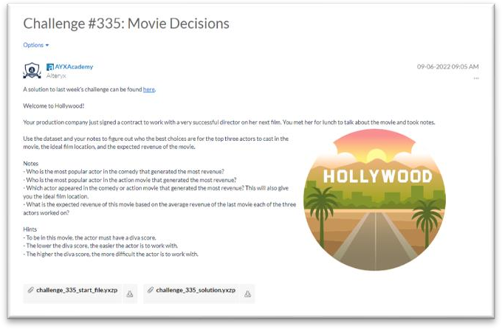

Dataset to download.

A list of Weekly Challenges to get you started:

|  |
| --- |
| [Challenge #164:](https://ayxlearn.info/WC-164) Retail Therapy |
| [Challenge #16:](https://ayxlearn.info/WC-16) Parsing Out the New-line Character |
| [Challenge #2:](https://ayxlearn.info/WC-2) Preparing Delimited Data |
| [Challenge #298:](https://ayxlearn.info/WC-298) Christmas Treasure Box |
| [Challenge #335:](https://ayxlearn.info/WC-335) Movie Decisions |
| [Challenge #338:](https://ayxlearn.info/WC-338) Let's Summarize! |
| [Challenge #68:](https://ayxlearn.info/WC-68) Elapsed Classroom Times |
| [Challenge #331:](https://ayxlearn.info/WC-331) Time for College! |
| [Challenge #145:](https://ayxlearn.info/WC-145) SANTALYTICS 2018 - Part 1 |
| [Challenge #168:](https://ayxlearn.info/WC-168) Dice Game - Born to Solve |
| [Challenge #321:](https://ayxlearn.info/WC-321) Eurovision |
| [Challenge #222:](https://ayxlearn.info/WC-222) Where There's a Whale There's a way |
| [Challenge #88:](https://ayxlearn.info/WC-88) Counting Combinations |
| [Challenge #46:](https://ayxlearn.info/WC-46) Formatting a Date from an Integer |
| [Challenge #120:](https://ayxlearn.info/WC-120) Popular Baby Names [Challenge #38:](https://ayxlearn.info/WC-38) Data Blending for Batch output [Challenge #35:](https://ayxlearn.info/WC-35) Data Cleansing Practice  [Challenge #322:](https://ayxlearn.info/WC-322) Good Ladies Heist |

# Full Core Blueprint

|  |  |
| --- | --- |
| **Core Blueprint** | **% of the Exam** |
| I. General Designer Knowledge and Optimization | 13% |
| II. Input/Output Data and Preparation | 36% |
| III. Blend Data and Parse | 26% |
| IV. Transform Data | 25% |
| **TOTAL** | **100%** |

1. **General Designer Knowledge and Optimization – 13%**
   1. Use Designer search and resources (e.g. Community, one tool examples, submitting support cases)
   2. Navigate the user interface
   3. Identify Alteryx native file formats
   4. Share and export workflows
   5. Optimize workflows by reducing run time and collaborate using documentation tools.
2. **Inputting/Outputting Data and Preparation – 36%**
   1. Read and write data (e.g. create text input, navigate data connections, input/output data options)
   2. Interpret common data types
   3. Cleanse data using the Data Cleansing tool
   4. Build formulas (e.g. reference formulas, conditional statements, indexes)
   5. Filter and arrange data using the following tools: Select, Select Records, Sort, Filter, Unique, Sample
3. **Blend Data and Parse – 26%**
   1. Perform unions, joins, and appends
   2. Leverage the Find and Replace tools
   3. Convert data string formats to and from date formats
   4. Delimit data with the Text To Columns tool
   5. Troubleshoot (e.g. duplication within joins, incompatible data types, mismatched fields)
4. **Transform Data – 25%**
   1. Apply the Summarize Tool
   2. Configure the Transpose Tool
   3. Apply the Cross Tab Tool (e.g. grouping data, methods of aggregation)
   4. Identify when to use the Transpose and Cross Tab tools in tandem

# Logo Description automatically generatedAppendix

**Alteryx Academy:** The Academy Team provides training content and programs to help Alteryx Community members become accomplished and highly skilled Alteryx Designer users.

**Alteryx Certification Home Page:** The Certification page reflects the user’s specific information; all available certifications are listed as well as FAQ and prep guides.

**Alteryx Support:** The team within Alteryx that provides Standard, Advanced, and Premium levels of support to the Alteryx Community. Users are able to submit a case, read articles, and access helpful documentation at no cost.

**Certification:** Achievement earned by an individual to verify their legitimacy and competence to perform a job. A certification from Alteryx refers to a passing score on one of the full certification exams.

**Credly:** Well-known digital badge management software. Every certification within our portfolio has a Credly badge associated with it that can be shared virtually. Credly is also the home of our PDF certificates.

**Micro-Certification:** Achievement earned by an individual to verify their legitimacy and competence to perform a job. A micro-certification from Alteryx refers to a passing score on one of the smaller certification exams.

**Open Book:** The exam is not proctored, and test takers are allowed to use training, notes, and resources listed in this prep guide.

**Question Types:** The exam includes multiple-choice, multiple-response, matching, and practical application questions. The questions in the practical application section gauge your ability to use the tools to solve problems. Practical application questions require you to connect to a provided dataset in Alteryx Designer to solve the problem.